Blue Team Shooting Sports Action Pistol December 9th, 2025
COURSE DESIGNER: Ike Starnes
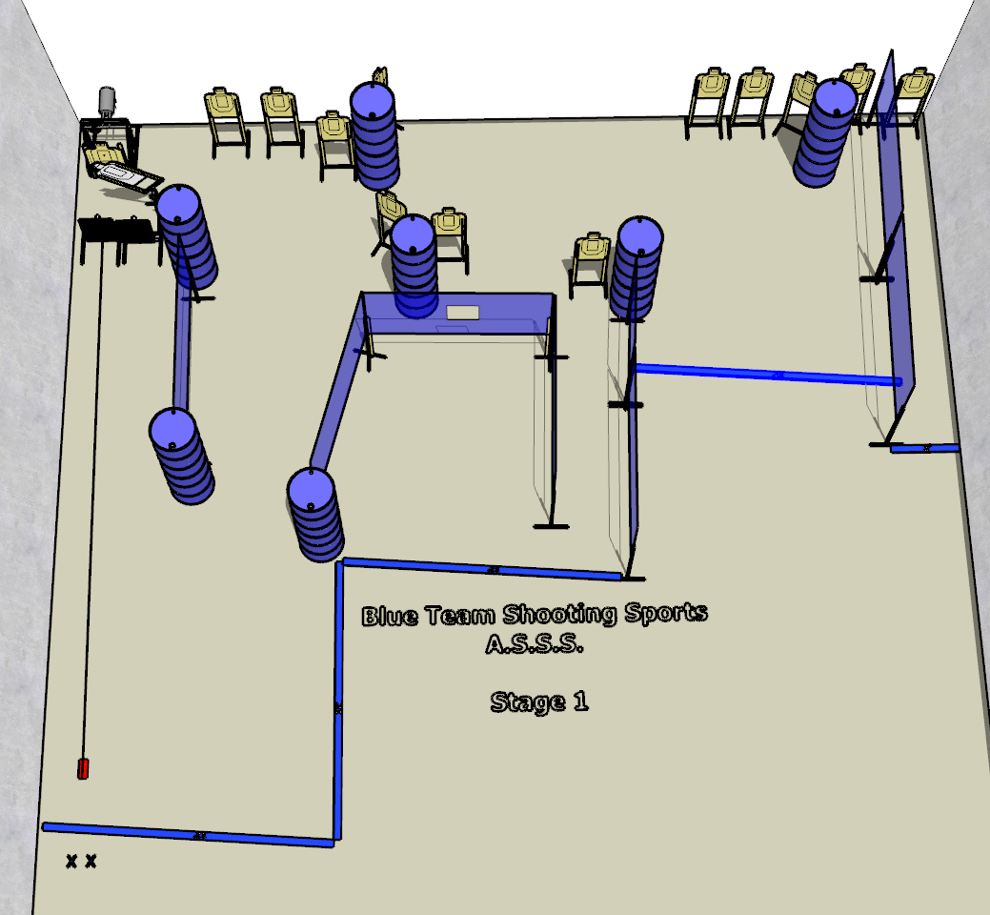

Written Stage Briefing:

Stage 1 – Well, you really can’t spell “families” without “lies.” - is a 26-round, 130 point, Comstock Course. There are 13 cardboard targets and some noshoots. The best 2 hits per cardboard target will be scored.
Handgun start position Feet on Xs, holding Santa’s bag. The handgun is loaded and holstered.
PCC start position Feet on Xs, holding Santas bag. PCC is loaded with stock touching belt.
The Aaron Banks Bobber must be activated by placing Santa’s Bag onto the Bigfoot activator. The bobber remains visible at rest.
On the audible start signal, engage all targets from within the shooting area.

